The **Build Monitor plugin** provides a visualization of the status and progress of selected Jenkins jobs. It displays an updated view automatically every couple of seconds using AJAX. It can easily accommodate different computer screen sizes too.

1. Go to Manage Jenkins à Manage Plugins àinstall Build Monitor plugin.

2. Go to Jenkins Dashboard à Click on New View. Click +

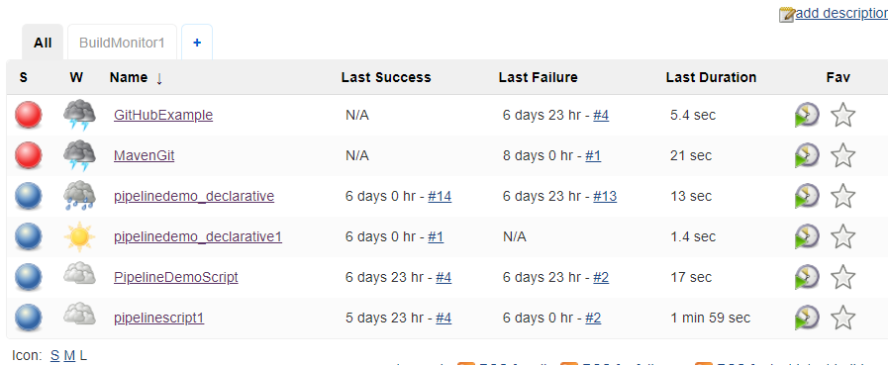

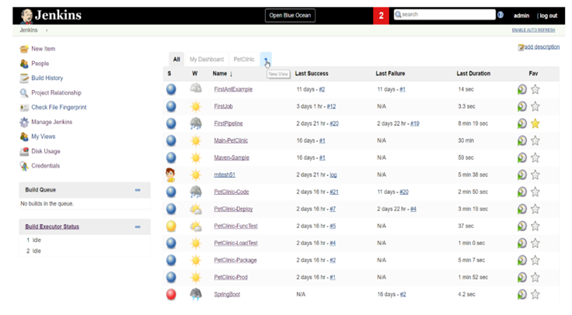

3. Type the name of view (e.g. MonitorProject-m) and click on Build Monitor View.

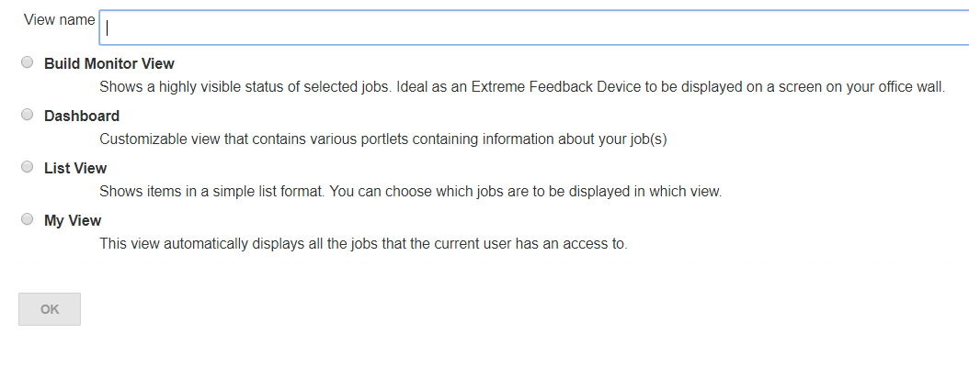

4. From the view window select the jobs to be monitored.

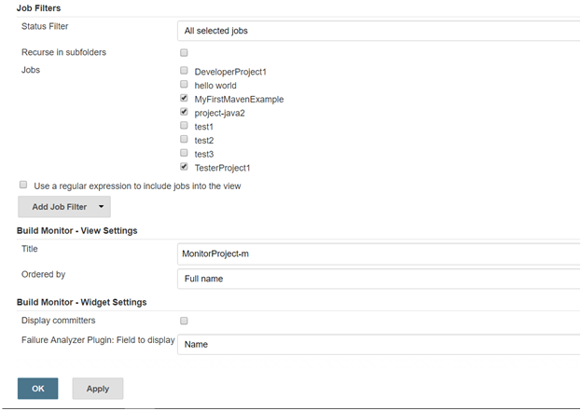

5. Click on apply and OK, and the monitor screen will appear.

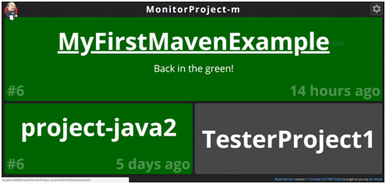

Current functionality of the Build Monitor plugin:

1. Displays the status and progress of selected jobs, the view is updated automatically every couple of seconds using AJAX. No "Enable Auto Refresh" needed.
2. Displays the names of people who might be responsible for "breaking the build".
3. Supports the [Claim plugin](https://wiki.jenkins.io/display/JENKINS/Claim+plugin), so that you can see who's fixing a broken build
4. Supports [View Job Filters](https://wiki.jenkins.io/display/JENKINS/View+Job+Filters), so that you can easily create Build Monitors for "slow builds", "only failing", etc.
5. Supports [Build Failure Analyzer](https://wiki.jenkins.io/display/JENKINS/Build+Failure+Analyzer), so that you know not only *who*, but also *what* broke the build; more [here](http://bit.ly/JBMBuild102)
6. Supports [CloudBees Folders Plugin](https://wiki.jenkins.io/display/JENKINS/CloudBees+Folders+Plugin), so that you can have project- and team-specific nested Build Monitors; more [here](http://bit.ly/JBMBuild117)
7. The number of columns and size of the font used is easily customisable, making it trivial to accommodate screens of different sizes.
8. UI configuration is stored in a cookie, making it possible to display different number of columns and using different font size on each of the screens at your office.